**Members:**

**L1F23BSSE0389 – Areef ur Rehman**

**L1F23BSSE0391 – Abdullah Maqbool**

**L1F23BSSE0395 – Muzaffar Ali**

**Inventory Management System Documentation**

**Project Overview**

The **Inventory Management System** is a desktop application designed to streamline and simplify inventory processes for warehouses. This system includes features for managing employees, suppliers, products, and orders. It provides role-specific dashboards for administrators and employees, ensuring efficient stock and supplier management. Built using **Java**, this system operates offline, offering a secure and user-friendly interface with a dark theme.

**Design and Architecture**

**1. System Roles**

**a. Administrator**

* Adds, removes, and views employees.
* Manages suppliers (add, remove, view).
* Oversees inventory records.

**b. Employee**

* Adds, removes, and views products.
* Manages orders (add, remove, view).

**2. Modules**

1. **Login Module**:
   * Authenticates users as Administrators or Employees.
   * Uses predefined credentials or validates from stored files.
2. **Employee Management**:
   * Enables Admin to add or remove employees.
   * Stores employee details in Employees.txt.
3. **Supplier Management**:
   * Facilitates supplier record addition and removal.
   * Stores supplier data in Suppliers.txt.
4. **Product Management**:
   * Allows Employees to manage product inventory.
   * Details stored in Products.txt.
5. **Order Management**:
   * Employees can create, delete, and view orders.
   * Order details saved in Orders.txt.

**3. File Handling**

Data is persisted using .txt files for employees, products, suppliers, and orders. Each action (add/remove) updates the corresponding file.

**4. GUI Design**

Built using **Java Swing**, the application provides a dark-themed, intuitive user interface:

* **Admin Dashboard**: Options for managing employees and suppliers.
* **Employee Dashboard**: Features for managing products and orders.

**Features**

**Administrator Features**

1. **Login**: Secure access with predefined credentials.
2. **Employee Management**:
   * Add employees.
   * Remove employees by ID.
   * View all employees.
3. **Supplier Management**:
   * Add new suppliers.
   * Remove suppliers by ID.
   * View all suppliers.

**Employee Features**

1. **Login**: Secure authentication using file-stored credentials.
2. **Product Management**:
   * Add new products.
   * Remove products by ID.
   * View product inventory.
3. **Order Management**:
   * Create new orders.
   * Delete orders by ID.
   * View all orders.

**Implementation Details**

**Tools and Technologies**

* **Programming Language**: Java
* **GUI Framework**: Java Swing
* **Data Storage**: File handling using .txt files
* **IDE**: IntelliJ IDEA or Eclipse

**Key Classes**

1. **Admin**:
   * Handles employee and supplier operations.
   * Manages admin-specific dashboard.
2. **Employee**:
   * Performs product and order-related tasks.
   * Accesses employee dashboard features.
3. **Product**:
   * Represents product details such as ID, name, price, and supplier.
4. **Supplier**:
   * Maintains supplier details, including ID, contact info, and performance history.
5. **Inventory**:
   * Core class handling file operations for products, suppliers, employees, and orders.
6. **LoginPage**:
   * Entry point of the application.
   * Authenticates users and redirects to respective dashboards.

**File Structure**

* **Employees.txt**: Stores employee details (ID, name, email, password, role).
* **Suppliers.txt**: Stores supplier information (ID, name, contact, performance).
* **Products.txt**: Stores product inventory (ID, name, price, quantity).
* **Orders.txt**: Logs orders (ID, date, status, product details).
* 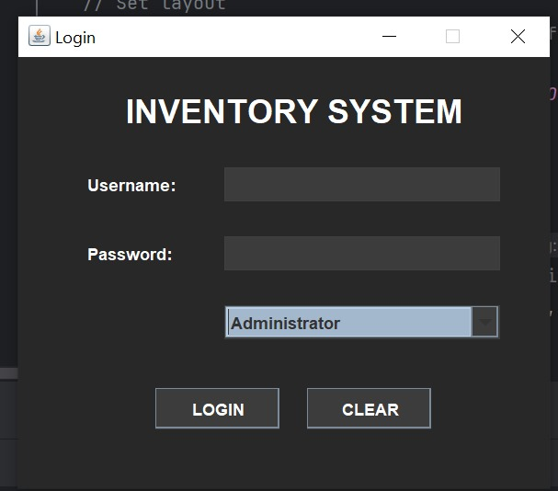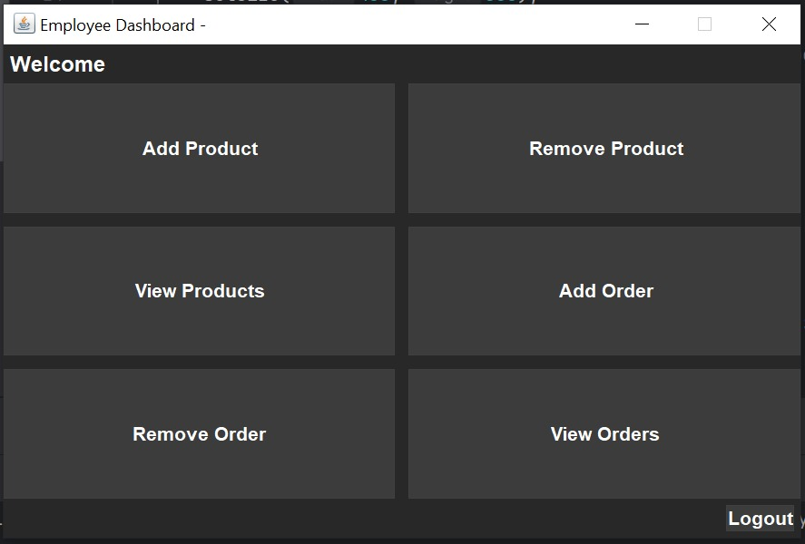
* 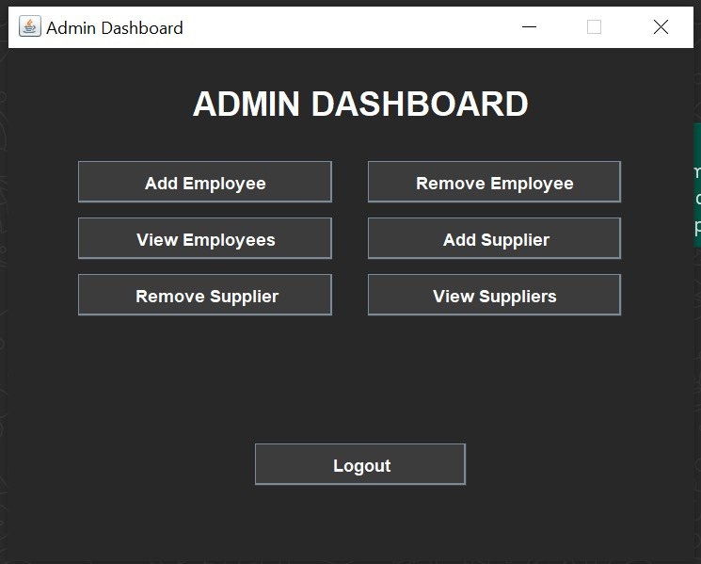

## Conclusion

The **Inventory Management System** enhances warehouse efficiency by offering a user-friendly platform to manage employees, products, suppliers, and orders. With role-specific functionalities and reliable data storage, the system ensures effective inventory control and smooth operations.